You are cordially invited to attend the
MSU Mathematics Education Colloquium

Wednesday, November 28, 2012
3:30 – 5 p.m., 252 Erickson Hall, MSU

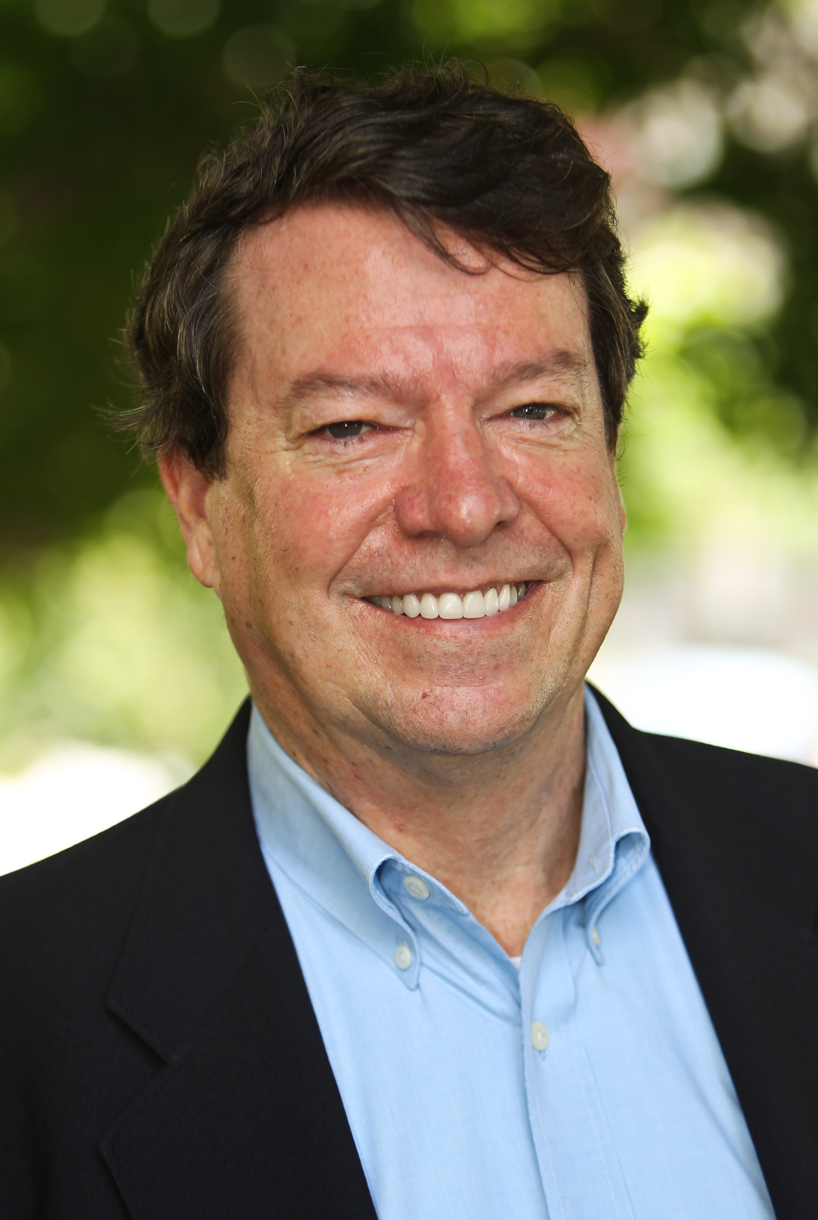 | Presented by:  Tom Loveless  Brookings Institution  Discussant:  Michael Weiss  Dept. of Teacher Education &  PRIME
The "Algebra for All" Movement: A Progress Report

The talk will discuss the past, present, and future of the national movement to require all students to complete algebra by 8th or 9th grades. What states and localities have pushed the hardest to implement such policies? What do we know about policy effects? How will "algebra for all" fare under the Common Core?

Tom Loveless is a senior fellow in Governance Studies at the Brookings Institution in Washington, D.C. Loveless’ research focuses on education policy and the politics of educational reform. He is the author of recent articles in the Wilson Quarterly, Education Next, American Journal of Education, Educational Policy, Educational Leadership, Educational Administration Quarterly, and Educational Evaluation and Policy Analysis. Loveless also authors The Brown Center Report on American Education, an annual report explaining important trends in achievement test scores. His op-eds have been published in The Christian Science Monitor, Los Angeles Times, Wall Street Journal, Newsday, The Washington Post, USA Weekend, The New York Times and Education Week. Loveless holds a Ph.D. in education from the University of Chicago, an M.A. in special education from California State University, Sacramento, and an A.B., in English from the University of California, Berkeley.
The Program in Mathematics Education sponsors this event.

