You are cordially invited to attend the
MSU Mathematics Education Colloquium

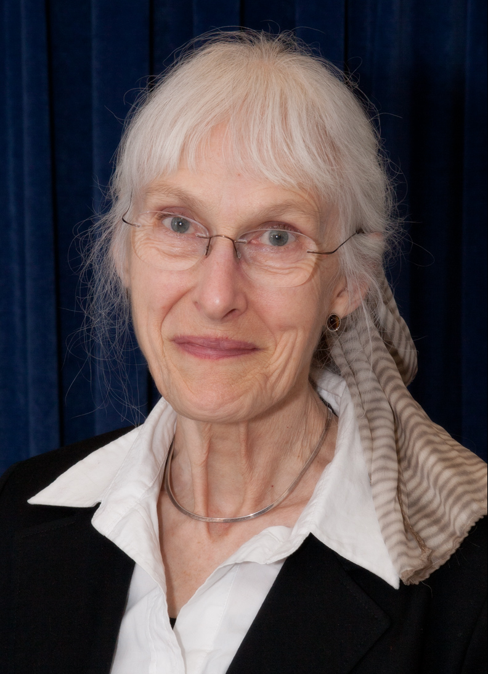 | Presented by:  Deborah  Hughes Hallett  University of Arizona
Wednesday,
October 30, 2013

3:30 – 5 p.m.
252 Erickson Hall
MSU

Calculus for the Class of 2020

How should we prepare students for calculus? In this talk we will draw on the experience of instructors in teaching calculus: What are the characteristics of successful calculus students? Where do students generally struggle? What mathematics do they need to know for calculus and what attitudes do they need to have? The high school Class of 2020 will be prepared by the Common Core State Standards, so we will look at the route to calculus provided by the Standards. We will talk about how instructors can use the Standards to enable students to excel both in calculus and in STEM fields at college.

Deborah Hughes Hallett is a Professor of Mathematics at the University of Arizona and Adjunct Professor of Public Policy at the Harvard Kennedy School. With Andrew M. Gleason at Harvard, she organized the Calculus Consortium based at Harvard and she is an author of several college level mathematics texts. Her work has been recognized by prizes from Harvard, the University of Arizona, the Association for Women in Mathematics, the Mathematical Association of America, and she was elected a fellow of the American Association for the Advancement of Science for contributions to mathematics education.

The Program in Mathematics Education sponsors this event.

